<!DOCTYPE html>

QUESTION 1

<html>

<head>

  <title>Time Table</title>

  <style>

    table, th, td {

      border: 1px solid black;

      border-collapse: collapse;

      text-align: center;

    }

  </style>

</head>

<body>

  <h1>Time Table</h1>

  <table>

    <tr>

      <th>Timings</th>

      <th>Mon</th>

      <th>Tue</th>

      <th>Wed</th>

      <th>Thu</th>

      <th>Fri</th>

    </tr>

    <tr>

      <th>9:00 - 9:40</th>

      <td>Math</td>

      <td>Science</td>

      <td>Math</td>

      <td>Science</td>

      <td>Arts</td>

    </tr>

    <tr>

      <th>9:40 - 10:20</th>

      <td>Math</td>

      <td>Science</td>

      <td>Math</td>

      <td>Science</td>

      <td>Arts</td>

    </tr>

    <tr>

      <th>10:20-10:40</th>

      <td colspan="5">Lunch</td>

    </tr>

    <tr>

      <th>10:40 - 11:20</th>

      <td>Math</td>

      <td>Science</td>

      <td>Math</td>

      <td rowspan="2" colspan="2" align="center">Project</td>

    </tr>

    <tr>

      <th>11:20 - 12:00</th>

      <td>Math</td>

      <td>Science</td>

      <td>Math</td>

    </tr>

  </table>

</body>

</html>

OUTPUT OF QUESTION 1

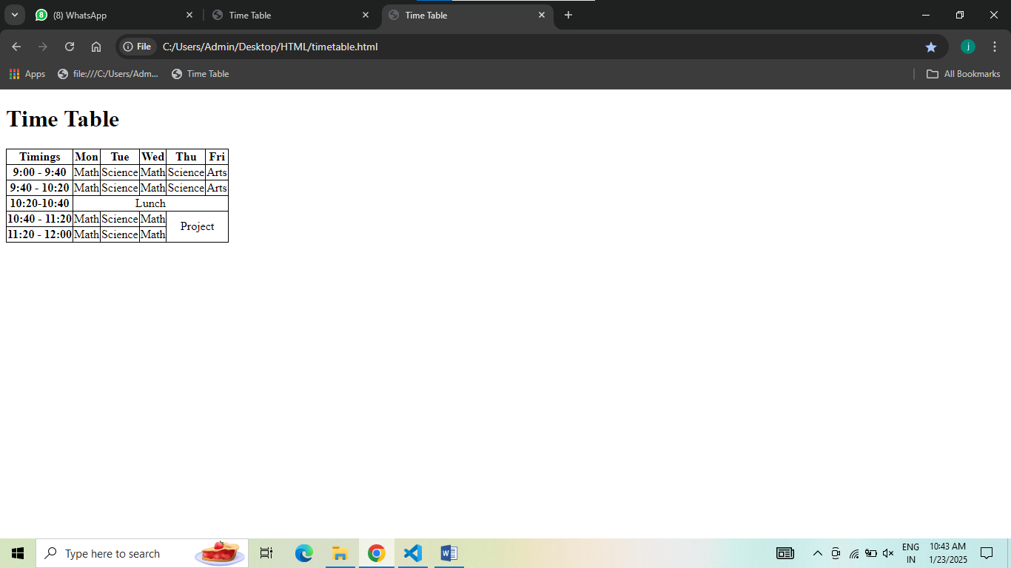

QUESTION 2

 <!DOCTYPE html>

<html>

    <head>

        <title>Time Table</title>

    </head>

    <body>

        <h1 align="center">Time table</h1>

        <table border="1" align="center">

            <tr>

                <th>Day period</th>

                <th>I 9:30-10:20</th>

                <th>II 10:20-11:10</th>

                <th>III 11:10-12:00</th>

                <th>12:00-12:40</th>

                <th>IV 12:40-1:30</th>

                <th>V 1:30-2:20</th>

                <th>VI 2:20-3:10</th>

                <th>VII 3:10-4:00</th>

            </tr>

            <tr>

                <td>Monday</td>

                <td>Eng</td>

                <td>Mat</td>

                <td>Che</td>

                <td rowspan="5" align="center">Lunch</td>

                <td colspan="3">LAB</td>

                <td>Play</td>

            </tr>

            <tr>

                <td>Tuesday</td>

                <td colspan="3">Lab</td>

                <td>Eng</td>

                <td>Che</td>

                <td>Mat</td>

                <td>SPORTS</td>

            </tr>

            <tr>

                <td>Wednesday</td>

                <td>Mat</td>

                <td>Phy</td>

                <td>Eng</td>

                <td>Che</td>

                <td colspan="3">LIBRARY</td>

            </tr>

            <tr>

                <td>Thursday</td>

                <td>Phy</td>

                <td>Eng</td>

                <td>Che</td>

                <td colspan="3">LAB</td>

                <td>Mat</td>

            </tr>

            <tr>

                <td>Friday</td>

                <td>Phy</td>

                <td>Eng</td>

                <td>Che</td>

                <td colspan="3">LAB</td>

                <td>Mat</td>

            </tr>

        </table>

    </body>

</html>

OUTPUT OF QUESTION 2

|  |  |  |  |  |  |  |  |  |  |  |  |  |  |  |  |  |  |  |  |  |  |  |  |  |  |  |  |  |  |  |  |  |  |  |  |  |  |  |
| --- | --- | --- | --- | --- | --- | --- | --- | --- | --- | --- | --- | --- | --- | --- | --- | --- | --- | --- | --- | --- | --- | --- | --- | --- | --- | --- | --- | --- | --- | --- | --- | --- | --- | --- | --- | --- | --- | --- |
| JFJTHIJRGJERG | ERHEHERUHE | FWEHFBEWHBFHEWB   |  |  |  |  |  |  |  |  |  |  |  |  |  |  |  |  |  |  |  |  |  |  |  |  |  |  |  |  |  |  | | --- | --- | --- | --- | --- | --- | --- | --- | --- | --- | --- | --- | --- | --- | --- | --- | --- | --- | --- | --- | --- | --- | --- | --- | --- | --- | --- | --- | --- | --- | | JFJTHIJRGJERG | ERHEHERUHE | FWEHFBEWHBFHEWB   |  |  |  |  |  |  |  |  |  |  |  |  |  |  |  |  |  |  |  |  |  | | --- | --- | --- | --- | --- | --- | --- | --- | --- | --- | --- | --- | --- | --- | --- | --- | --- | --- | --- | --- | --- | | JFJTHIJRGJERG | ERHEHERUHE | FWEHFBEWHBFHEWB   |  |  |  |  |  |  |  |  |  |  |  |  | | --- | --- | --- | --- | --- | --- | --- | --- | --- | --- | --- | --- | | JFJTHIJRGJERG | ERHEHERUHE | FWEHFBEWHBFHEWB   |  |  |  | | --- | --- | --- | | JFJTHIJRGJERG | ERHEHERUHE | FWEHFBEWHBFHEWB | |  |  |  | |  |  |  | | |  |  |  | |  |  |  | | |  |  |  | |  |  |  | | |  |  |  | |  |  |  | |
|  |  |  |
|  |  |  |

